**The relationship among FT, DTFT, DFT, and z-transform.**



**ID:201224020110**

**Name: BOUKARKAR ABDELHEQ**

**UESTC 2013/2014**

**Introduction:**

Fourier methods are commonly used for signal analysis and system design in modern telecommunications, radar, and image processing systems. Classical Fourier methods such as the Fourier series and the Fourier integral are used for continuous time signals and systems. A more recently developed set of Fourier methods, including the discrete time Fourier transform (DTFT) and the discrete Fourier transform (DFT), are extensions of basic Fourier concepts that apply to discrete time signals. The class of DT Fourier methods is particularly useful as a basis for digital signal processing (DSP) because it extends the theory of classical Fourier analysis to DT signals and leads to many effective algorithms that can be directly implemented on general computers or special purpose DSP devices. The following discussion presents **basic concepts and outlines important** **properties for FT, DTFT, DFT, and Z-transform,** **with a particular emphasis on the** **relationships between them**.

**1-The Fourier Transform:**

**Definition:**

Given a function, how can we determine how often each frequency occurs in it? And how do these frequencies relate to? The answer to these questions can be found using the **F**ourier **T**ransform of , denoted by :

 And the inverse FT is given by this equation:



**Some proprieties of Fourier Transform**:

**Linear:** Fourier Transform is an integral, and it is a linear operation:

 

Then: 

**Time shift:** Signal’s shift in time domain equals phase shift in frequency domain



**Frequency shift: (Modulation theorem)** 

**Relationship between FT and DTFT:**

The FT is applied on continuous signals; however the DTFT (we will explain it in the next section) is applied on discrete signals.

To obtain a discrete signal, we apply the sampling process, using the impulse train.

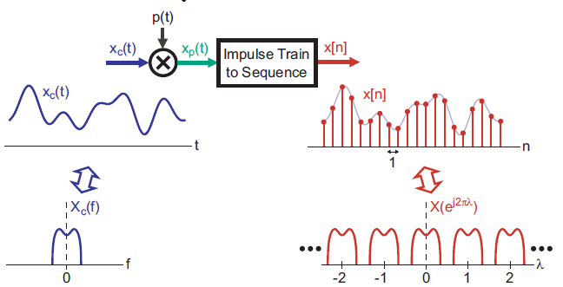

|  |  |  |
| --- | --- | --- |
|  | **FT** | **DTFT** |
| Time | Continuous, Non-Periodic | Continuous, Non-Periodic |
| Frequency | Non-Periodic, Continuous | Non-Periodic, Discrete |

Relationship between FT and DTFT

**2-DTFT(Discrete Time Fourier Transform):**

**Definition:**

DTFT is a frequency analysis tool for aperiodic discrete-time signals. The Discrete-Time Fourier Transform (DTFT)  of a sequence x[n] is given by:



In general,  is a complex function of the real variable  and can be written as



 can alternately be expressed as: .

Where 

 is called the magnitude function.  is called the phase function.

**Example:**

The DTFT of the unit sample sequence is given by:



The DTFT of a sequence x[n] is a continuous function of .It is also a periodic function of ω with a period 2π. Inverse Discrete-Time Fourier Transform: 

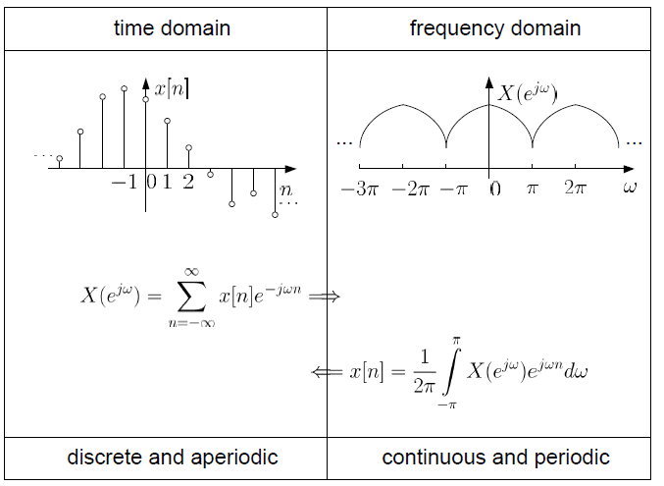

Illustration of DTFT.

**DTFT proprieties**:

There are a number of important properties of the DTFT that are useful in signal processing applications.

This table presents the important proprieties of the DTFT:



DTFT proprieties

After giving the definition of the TDFT, now we will introduce the DFT and we will explain the relationship between them (TDFT and DFT).

**3-DFT(Discrete Fourier Transform):**

**Definition:**

**The Discrete Fourier Transform (DFT) is the equivalent of the Continuous Fourier Transform for signals known only at 􀀀 instants separated by sample times _(i.e. a finite sequence of data).**

For a length-N sequence x[n], defined for  only N samples of its DTFT are required, which are obtained by uniformly sampling on the -axis between at ωk=2πk/N, 0≤k≤N-1.

From the definition of the DTFT we thus have: 

X[k] is also a length-N sequence in the frequency domain. The sequence X[k] is called the Discrete Fourier Transform (DFT) of the sequence x[n].

**Relationship between DTFT and DFT:**

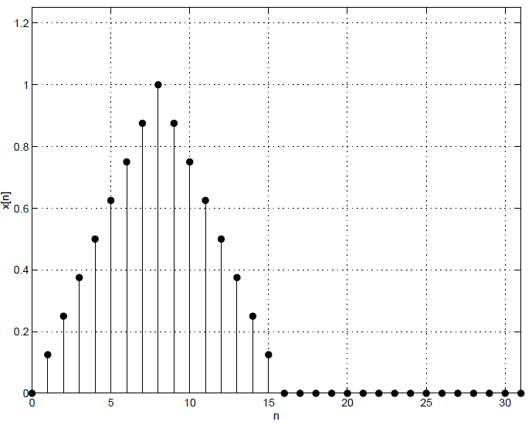**is the uniform samples ofat the discrete frequency , when the** frequency range [0, 2π] is divided into N equally spaced points. Let’s use Matlab to represent the DTFT and the DFT of a sequence, N=32 to see the relationship between them.

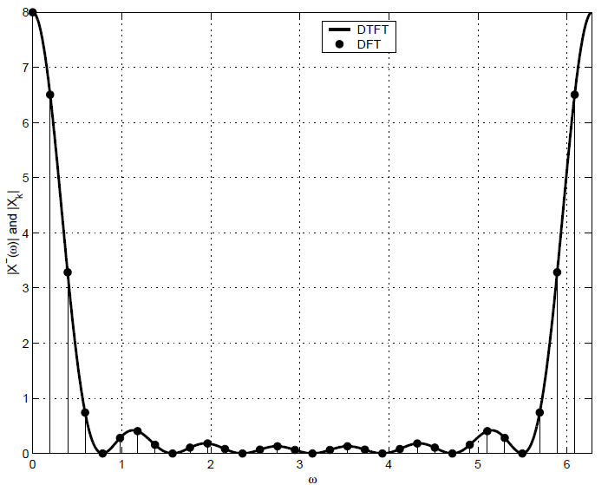

The DTFT and the DFT of the sequence x[n].

**Interconnections between FT, DTFT, and DFT:**

The Fourier Transform FT, the Discrete Time Fourier Transform DTFT, and the Discrete Fourier Transform DFT, are all interconnected via the sampling process. **Our intention here is to show these interconnections.**

**Sampling:**

Let us consider a continues time signaland its sampled signal :  (1)

Where T is the sampling period, and  the Sampling frequency in Hz.  Sampling frequency in Rad/Sec.

Since the impulse train  is periodic with a period T, we can first construct its Fourier series as, and then rewrite  as:  (2)

We can now take the Fourier Transform of the above equation to get:  (3)

The above equation relates the Fourier Transform of the sampled signal to that of the original signal. As seen clearly, is obtained by replicating infinite number of times in frequency domain. This is often quoted as Sampling in time domain replicates the spectrum in frequency domain. We can also rewrite as:

 (4)

We can also take the FT of the above equation to get:  (5)

Thus there are two equivalent expressions for, one as given by (3), and another as given by (5). As said earlier, equation (3) is the underlying basic expression that leads to sampling theorem. On the other hand, equation (5) is the underlying basic expression that leads to Discrete Time Fourier Transform **DTFT**. So we can see clearly that the **FT** and the **DTFT** are interconnected.

Now suppose that we have a finite sequence of numbers x[0], x[1], x[2]…, x[N-1]. We can define a DTFT for this sequence as we discussed earlier, DTFT is periodic in Ω and we need to evaluate it only for 0≤ Ω < 2π. Now let us discretize the DTFT and evaluate it only at:

Ω=0, Ω=2π/N, Ω=2*2π/N,…,Ω=(N-1)* 2π/N.

Then we get a finite sequence of numbers representing DTFT. This finite sequence of numbers is known as **Discrete Fourier Transform DFT**. So we have a connection between the DTFT and the DFT.

**Z-Transform:**

The DTFT provides a frequency-domain representation of discrete-time signals and LTI discrete-time systems. Because of the convergence condition, in many cases, the DTFT of a sequence may not exist. As a result, it is not possible to make use of such frequency-domain characterization in these cases.

A generalization of the DTFT defined by:  leads to the z-transform.

z-transform may exist for many sequences for which the DTFT does not exist. Moreover, use of z-transform techniques permits simple algebraic manipulations. Consequently, z-transform has become an important tool in the analysis and design of digital filters.

For a given sequence**** , its z-transform**** is defined as : 

Where  is a complex variable. If we let  , then the z-transform

reduces to :  this equation can be interpreted as the **DTFT** of the modified sequence: {****}

For r = 1 (i.e., |z| = 1), z-transform reduces to its DTFT, provided the latter exists.

**Conclusion:**

The digital signal processing is very important domain. It has many applications, [audio signal processing](http://en.wikipedia.org/wiki/Audio_signal_processing), [audio compression](http://en.wikipedia.org/wiki/Audio_compression_(data)), [digital image processing](http://en.wikipedia.org/wiki/Digital_image_processing), [video compression](http://en.wikipedia.org/wiki/Video_compression), [speech processing](http://en.wikipedia.org/wiki/Speech_processing), [speech recognition](http://en.wikipedia.org/wiki/Speech_recognition), digital communications, RADAR, SONAR, seismology and biomedicine. In this discussion we have presented some concepts and important properties of FT, DTFT, DFT, and Z-transform, including showing the relationships between them. We have discussed the following points:

* FT definition and proprieties;
* The relationship between FT and DTFT;
* DTFT definition and proprieties;
* DFT definition and proprieties;
* The relationship between DTFT and DFT;
* Interconnections between, FT, DTFT, DFT;
* z-transform and its relationship with DTFT.